Scissors, paper, rock
1. Go to the “Games Menu” and click on it.
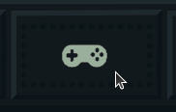

2. Click the symbol of 3 hands.
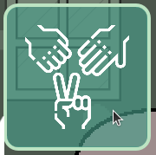

3. You will then see a screen like below.
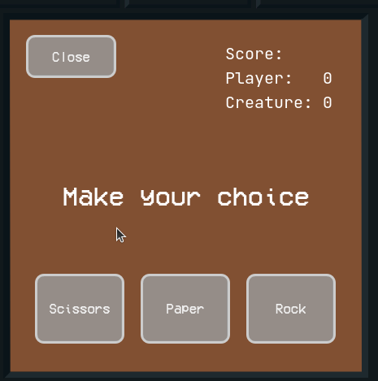

4. Click 1 of the 3 options, scissors, paper or rock.
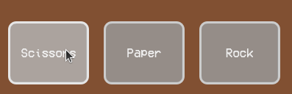

5. The creature will then choose 1 of the 3 options, depending on what the creature chooses you will either:
win
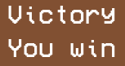

Tie


or Lose
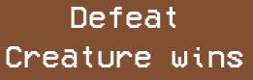

Please note:
Scissors beat Paper
Paper beats Rock
Rock beats Scissors

6. You can repeat steps 4 – 5 as many times as you like and the score will be shown in the top right corner of the screen.
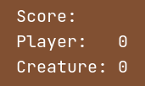

Memory
1. Go to the “Games Menu” and click on it.

2. Click the symbol of cards.
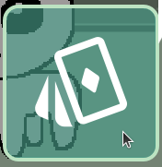

3. You will then see a screen like below.
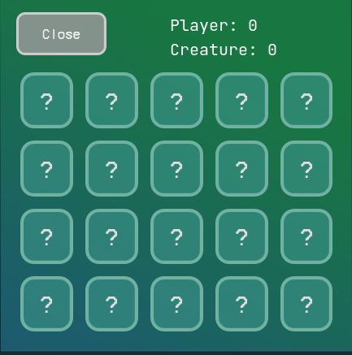

4. Click on 1 of the tiles with a ?, it will then show a number.
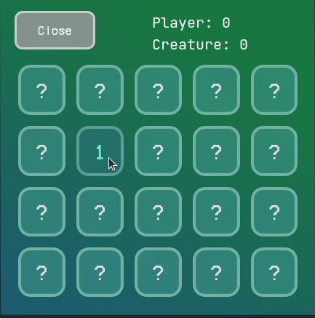

2. Click the symbol of

Try to remember what tile you clicked and the number on it.
5. After you have clicked 1 of the tiles, choose another and click on that one.
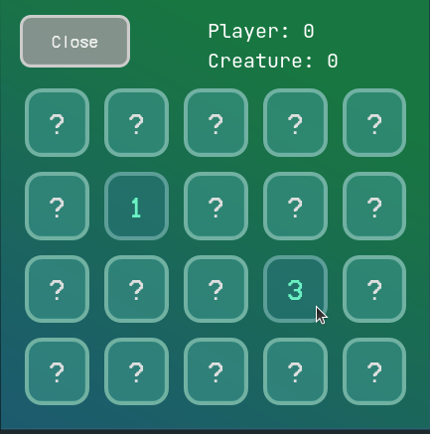

Also try to remember that tile and its number as well.
6. After a short moment the tiles will return to showing ?.
7. Repeat steps 4 – 5 until you find a pair: 2 tiles with the same number on them.
8. After you have found a pair the 2 tiles will then show a picture of an X.
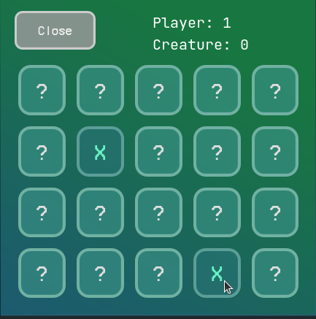

9. As you click on more tiles you will start to remember where each number is, try and get as many pairs in a row without missing one.
10. The game ends when all pairs are found.

Totris
1. Go to the “Games Menu” and click on it.

2. Click the symbol of a block.
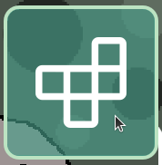

3. You will then see a screen like below.
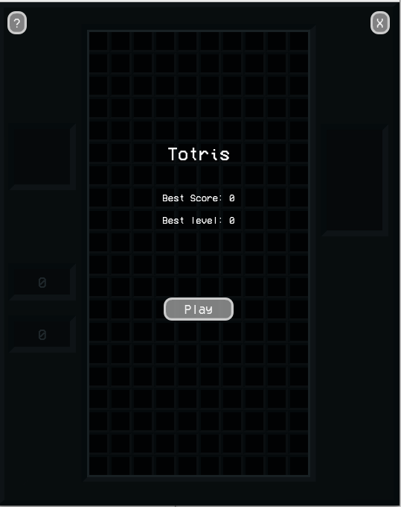

4. Once you see that screen click the “Play” button.
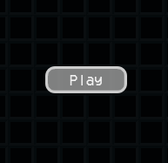

5. As soon as you click the “Play” button the game will start. You should then see a screen like the one below.
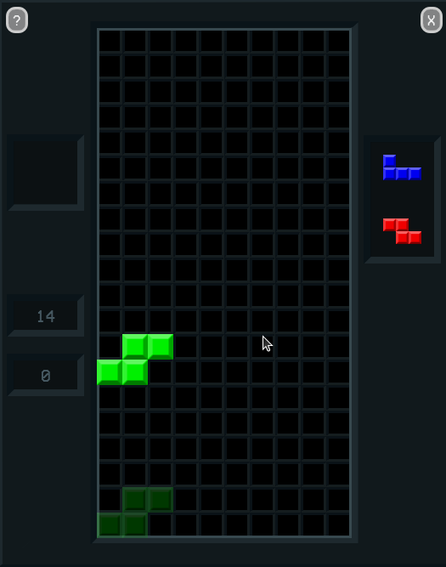

6. The goal of the game is to connect the falling blocks together inside the grid for as long as you can. As you place more and more blocks the pace at which the blocks fall will get faster and faster. You lose if the blocks reach the top of the grid.
This is the grid. The block on the grid is the block you are currently placing.
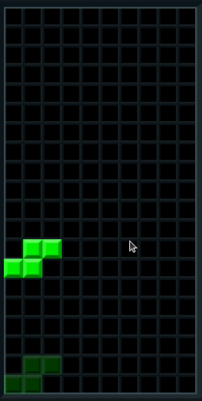

This is the block queue. This shows you what blocks you will be given next. Top first, bottom second.
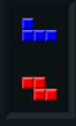

This is the score board. The top box is your score and the bottom box is the level you are on.
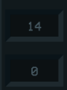

7. To move around and place the blocks you will use the A, S, D, Q and E keys on your keyboard.
Use A to move the blocks to the left.
Use D to move the blocks to the right.
Use S to make the blocks fall faster.
Use Q to rotate the blocks left.
Use E to rotate the blocks right.
8. If a row in the grid is completely filled with blocks that row will disappear freeing up space on the grid and increasing your score.
9. Continue playing the game trying to get the highest score you can, until the blocks reach the top of the grid and the game ends.

